# GEF 5 Progress Report: Remote Sensing of Carbon Stocks in Subtropical Thicket

## Dugal Harris - March 2017

# Introduction

This report summarises the first phase of work which addressed the development of a technique for the canopy cover mapping of *P. afra* (Spekboom) using very high resolution (VHR) aerial imagery.

Subtropical thicket has been degraded by overgrazing throughout much of its range in the Eastern Cape and Little Karoo (Marais et al., 2009; Mills et al., 2005; Sigwela et al., 2009). There is substantial interest in thicket restoration and a growing body of research. There are numerous benefits to the restoration of degraded thicket habitat through planting *P. afra*. These include improved soil fertility and water retention, restoration of biodiversity, potential for the generation of carbon credits due to *P. afra’s* high carbon sequestration capability, and generation of employment in impoverished areas (Mills et al., 2010; Mills and Cowling, 2006; van der Vyver et al., 2013; van Luijk et al., 2013). At present, VHR canopy cover maps of *P. afra* are required to assist with restoration work on private land in the Little Karoo. Canopy cover is currently measured manually by visual inspection in the field. This method is time-consuming, impractical for remote locations and prone to repeatability problems.

This work sought to address the need for canopy cover maps through the development of a per-pixel *P. afra* classifier for 0.5m multi-spectral aerial imagery. This imagery was obtained from National Geo-spatial Information (NGI) which flies aerial surveys of South Africa roughly every three years and provides imagery free of charge to the public (National Geo-spatial Information, 2012). A portion of the Little Karoo, as shown in Figure 1.1, was chosen as the study area. This area contains all of the biomes and nine of the ten habitat types that support *P. afra* (Vlok et al., 2005)*.* It also consists of four different aerial survey jobs, flown at different times. High resolution remote sensing of vegetation over large spatial extents is still a relatively unexplored area of research, especially in arid areas (Eisfelder et al., 2012). Variations in habitat and level of degradation, in addition to radiometric variations in the imagery, make this a challenging problem.

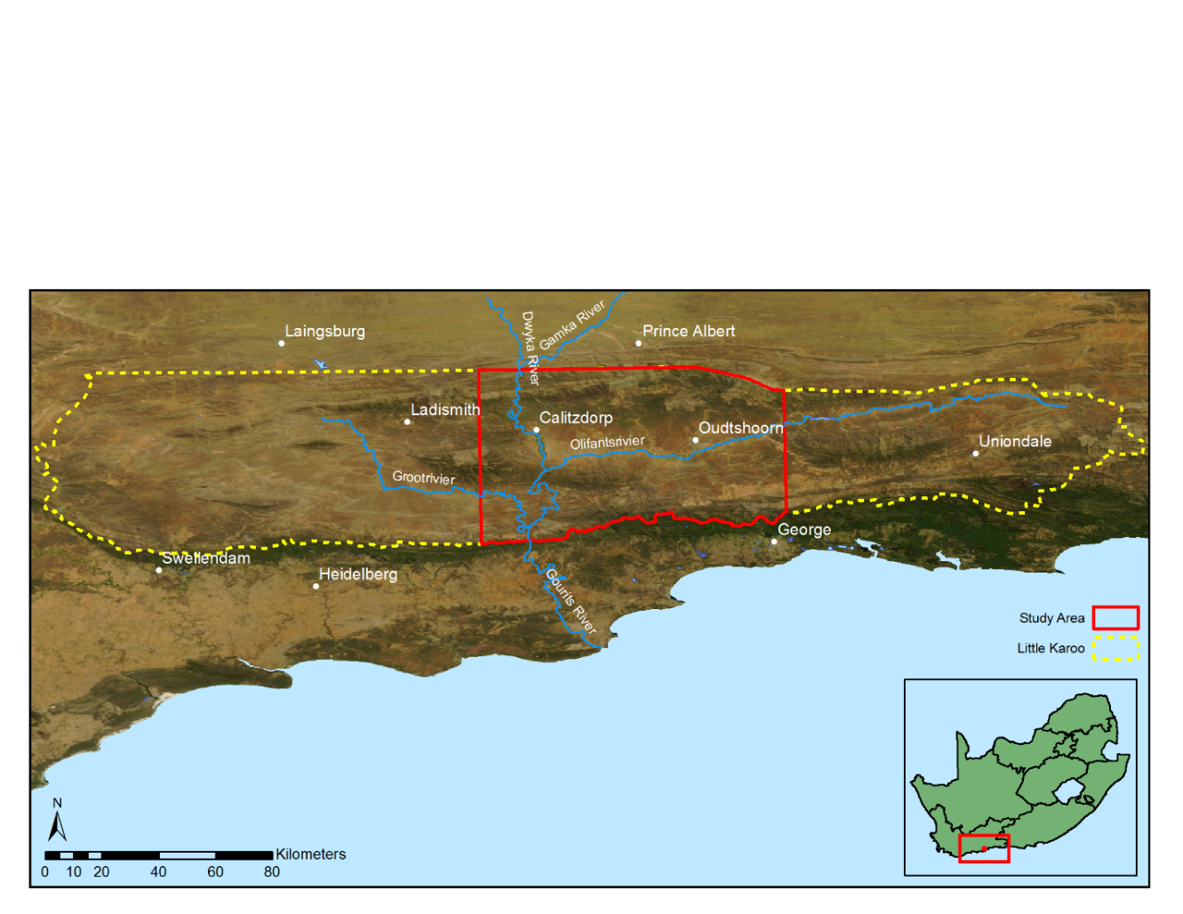

Figure 1.1 Little Karoo study area

# Image Calibration (Coarse Scale Surface Reflectance Homogenisation by Calibration with Satellite Data)

Quantitative remote sensing over large spatial scales or at repeated time intervals requires radiometrically consistent imagery. Ideally, imagery should be calibrated to some physical property of the land surface such as reflectance. Available NGI orthorectified imagery of the study area is not calibrated and has been processed with the intention of producing aesthetically pleasing imagery for visual interpretation. Processing steps include Look Up Table (LUT) and dodging adjustments, which are damaging to surface reflectance information. The orthorectified NGI imagery is unsuitable for this study and it was therefore necessary to perform radiometric correction on the raw, direct-from-camera NGI imagery.

A number of techniques for the radiometric correction of aerial image mosaics exist (Chandelier and Martinoty, 2009; Collings et al., 2011; Gehrke, 2010; López et al., 2011). Their use was not practical however, due to the need for vicarious measures of surface reflectance at the time of image capture and the complexity of atmospheric and BRDF (Bi-directional Reflectance Distribution Function) corrections. A novel approach for calibrating aerial image mosaics to coarse-scale surface reflectance was developed. In this approach, a collocated and concurrent well calibrated satellite image provides a surface reflectance reference to which the mosaic is calibrated. The satellite image needs to be spectrally similar to the aerial imagery. A spatially varying linear model is used to approximate the relationship between surface reflectance and sensor measurement. The model parameters are found via a least squares fit inside a sliding window. Atmospheric and BRDF corrections are achieved implicitly. Note, however, that small scale BRDF variations are not captured at the satellite resolution and cannot be corrected for by the method.

The raw NGI imagery was corrected for camera effects using proprietary software from Intergraph. Following this, the calibration method was applied to the camera-corrected imagery. A concurrent MODIS MCD43A4 500m image was used as the reflectance reference. Figure 2.1 shows the raw uncalibrated image mosaic against a background of the MODIS reference. Discontinuities between adjacent images due to BRDF and atmospheric effects are apparent. It is also clear that there is not a good match between the aerial imagery and background MODIS reference. Figure 2.2 shows the mosaic calibrated with the described technique. With no obvious discontinuities between adjacent images and a good match between the mosaic and reference images, the result is visually compelling.

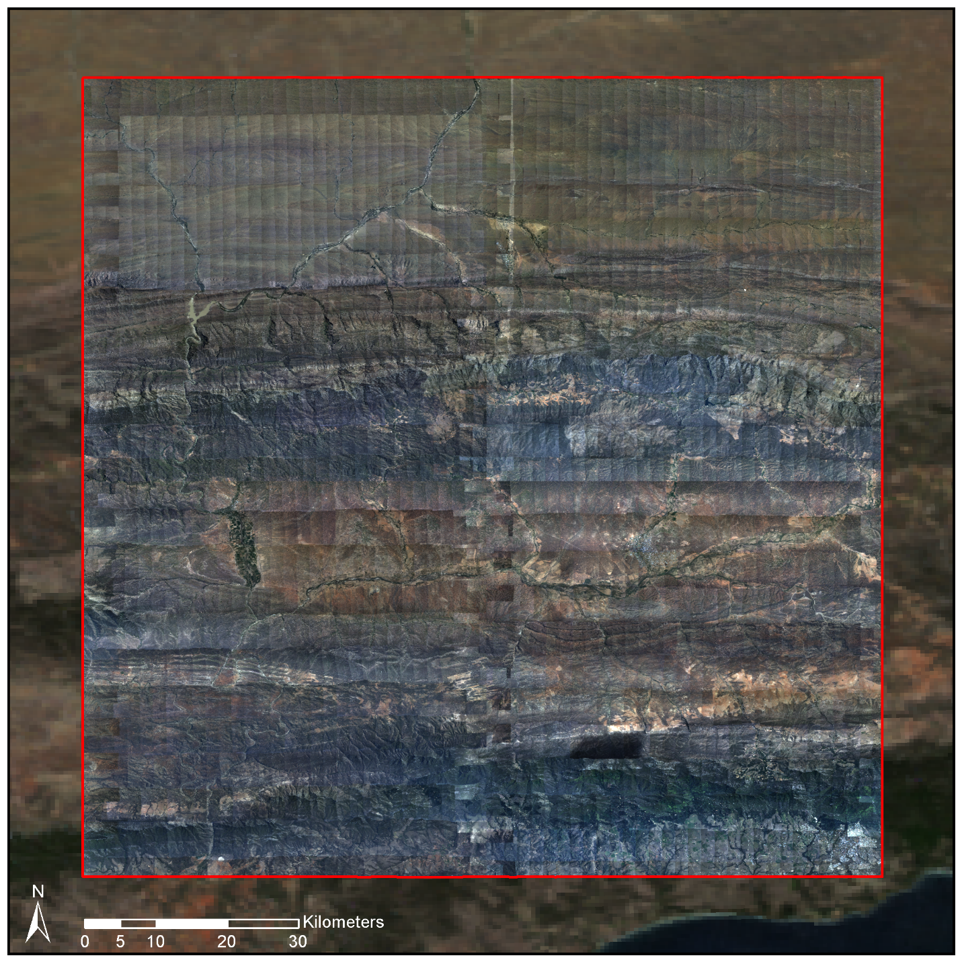

Figure 2.1 Camera calibrated mosaic on MODIS reference image background

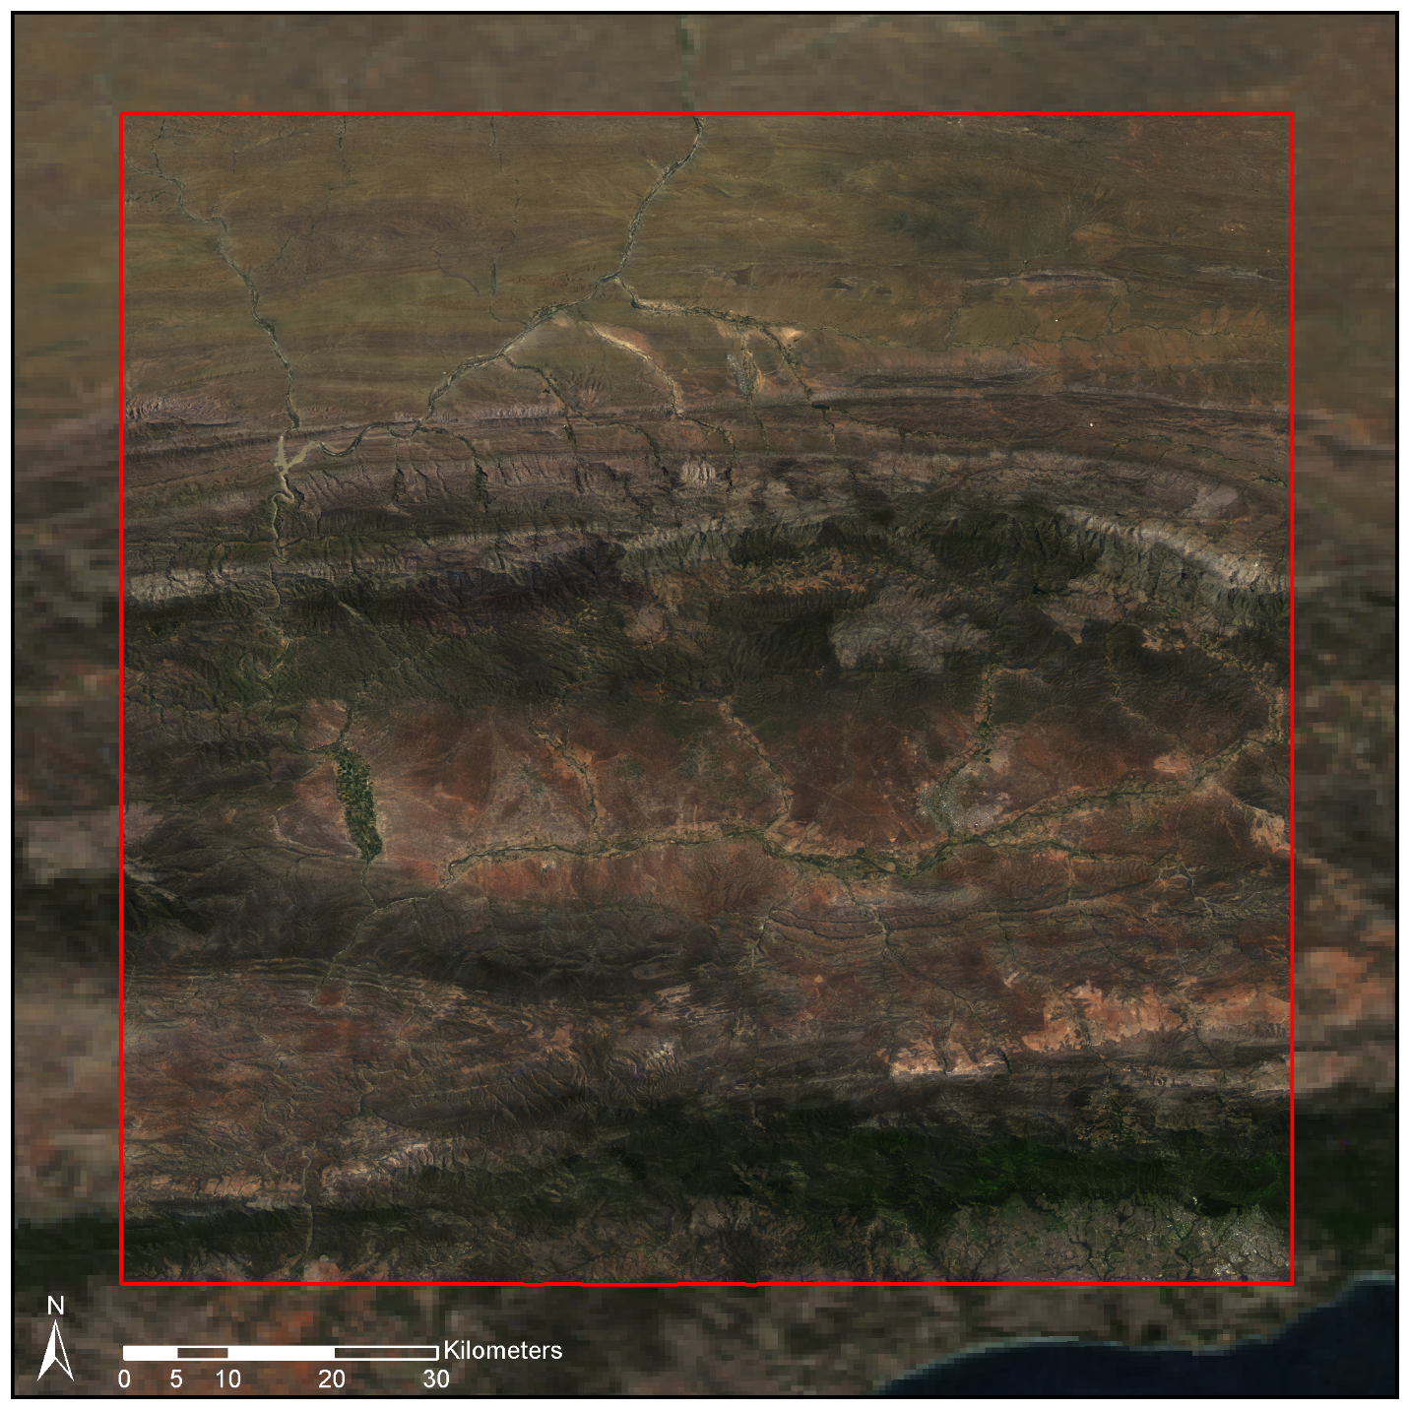

Figure 2.2 Radiometrically calibrated mosaic on MODIS reference image background

In order to quantitatively test the accuracy of the calibration, a SPOT 5 scene was compared to the calibrated mosaic. The SPOT resolution of 10m allows the calibration result to be checked at a resolution significantly closer to the uncalibrated resolution than the reference MODIS resolution. The SPOT image was orthorectified and corrected for sensor and atmospheric effects using the ATCOR 3 algorithm to give surface reflectance. Since the SPOT sensor does not have a blue band, it was omitted from this validation. The colour-infrared (CIR) NGI mosaic and SPOT images shown in Figure 2.3 are very similar. The difference image is mostly dark, indicating a good match between the SPOT and mosaic images. A mean overall reflectance error of 4.2% suggests the calibration method is effective and compares well with related studies (Collings et al., 2011; López et al., 2011).

|  |  |
| --- | --- |
|  |  |
| (a) | (b) |
|  | |
| (c) | |

Figure 2.3 Calibration validation. (a) Masked NGI mosaic. (b) SPOT scene. (c) Contrast stretched absolute difference image.

# Feature extraction and selection

For the purposes of training a classifier, image ground truth was produced by selecting and hand labelling polygons in the imagery. Only objects where there was a reasonable degree of confidence of class membership were included. A labelling scheme of three classes, as described in Table 3.1, was adopted. While canopy cover mapping is in essence a two class problem (*P. afra* and everything else), the addition of the third Tree class provided increased flexibility and diagnostic information when designing the classifier.

Table 3.1 Class descriptions

|  |  |
| --- | --- |
| Class Name | Description |
| Spekboom | *P. afra* |
| Tree | Any recognisable tree but especially the darker *Euclea* and *Pappea* trees commonly found intermingled in stands of *P. afra*. |
| Background | Bare ground, small shrubs, herbs and anything else not included in the first two classes. |

A set of 46 features that would aid in describing the visual characteristics of *P. afra* were evaluated. This set included a fairly typical combination of spectral features, vegetation indices and texture features. While the spectral resolution of the VHR imagery is poor, the spatial resolution allows description of vegetation structure and spatial patterns that is not possible with lower resolution satellite imagery. Texture is recognised as an important feature in vegetation mapping (Lu, 2006; Singh et al., 2014). Sliding window texture features were included to try and exploit this source of information in distinguishing the classes.

It was found that there was significant correlation amongst these features partially due to heavily overlapping spectral bands in the Intergraph DMC camera sensor used by NGI (Intergraph, 2008). This is a typical property of high dimensional and aerial feature sets (Sahu and Mishra, 2011; Yousef et al., 2007). Traditional feature selection approaches such as forward selection and backward elimination, are prone to instability and selection of sub-optimal feature sets in these circumstances (Strobl et al., 2008; Tolosi and Lengauer, 2011; Yousef et al., 2007; Yu and Liu, 2004). These problems were empirically confirmed on the extracted features. As a means of circumventing these difficulties, a method for ranking features that is robust to correlation was devised. This “feature clustering and ranking” method uses hierarchical clustering to group correlated features into clusters. Clusters are ranked based on the performance of a naïve Bayes classifier or Mutual Information criterion on their constituent features. Individual features can then be hand selected from the highest ranked clusters. Other factors such as computational speed and ease of interpretation can also be considered when making this selection. The method was compared to standard feature selection approaches by comparing its accuracy and stability performance on a number remote sensing data sets containing correlation. The stability of selected features under different data samplings was shown to be significantly improved with the new method. Using the procedure, a subset of six features was selected, giving priority to fast-to-compute features. The selected features produced good accuracies across a variety of classifiers.

# VHR Mapping of *P. Afra* Canopy Cover

A statistical pattern recognition approach was followed to classify *P. afra* canopy. The pixel size of 0.5m, combined with the tendency of *P. afra* to grow in continuous stands meant that there was little spectral mixing and pixels covering *P. afra* were relatively pure. This supported a hard per-pixel classification approach. The fractional canopy cover was determined as the portion of pixels classified as *P. afra* over an area of interest. The classifier produced maps were post processed using morphological operators to remove noise and smooth boundaries. These operations can be seen as a way of further incorporating spatial context into the classification results.

Support Vector Machine (SVM), random forest, decision tree, K-Nearest Neighbour (KNN) and Bayes normal classifiers were evaluated against both the hand labelled image ground truth and canopy cover ground truth, acquired at 20 field sites with Jan Vlok. All classifiers except the Bayes normal classifier performed similarly well, confirming that an informative feature subset had been chosen. The poor performance of the Bayes normal classifier can be attributed to the non-normal distribution of the feature set. The decision tree produced the best results on the field ground truth and was chosen as the final classifier. It was also one of the fastest classifiers evaluated, being second in speed to the Bayes normal classifier. Due to the large volume of two terabytes of imagery requiring processing, computation speed was an important factor in the choice of features and classifier.

The confusion matrix for the decision tree performance on the image ground truth is shown in Table 4.1. The performance on the field ground truth is shown for each site in Table 4.2. The mean of the absolute canopy cover errors is 5.85% with a standard deviation of 4.65% over the 20 sites.

The classifier performs well in the Groenfontein, Matjiesvlei and Grootkop areas but underestimated canopy cover for the Rooiberg sites. An inspection of the images of the field sites suggested that the Rooiberg ground truth estimates were somewhat inflated. This could be because the Rooiberg site was in recovery and the *P. afra* plants had grown significantly in the three years between image capture and ground truthing, or it could simply be due to human error. Overlaying the classifier output maps on the imagery did however indicate that the classifier was also underestimating the actual canopy extent. The Rooiberg site was a working farm until 2000 when it was set aside as a conservation area and allowed to begin recovering from the grazing of domesticated livestock. As a result of this, and the sandstone/quartzite geology of the area, the *P. afra* plants at Rooiberg are smaller and have a canopy that is less dense than those in other sites. This helps explain the canopy cover underestimation in this area.

As an additional check on the classifier performance, comparative canopy cover estimates were made for the field sites by Jan Vlok using only the images and without knowledge of the field ground truth. The mean absolute error (MAE) and standard deviation of absolute errors (SAE) of these expert estimates were 17.50% and 20.98% respectively, which is regarded as further confirmation of the classifier’s usefulness.

Table 4.1 Decision tree two class confusion matrix

|  |  |  |  |  |
| --- | --- | --- | --- | --- |
|  | Background | Spekboom | Total | PA (%)a |
| **Background** | 30103 | 514 | 30617 | 98.32 |
| **Spekboom** | 1491 | 25769 | 27260 | 94.53 |
| **Total** | 31594 | 26283 | 57877 |  |
| **CA (%)a** | 95.28 | 98.04 |  |  |
| **Kappa** | 0.93 |  |  |  |
| **Overall Error (%)** | 3.57 |  |  |  |

a CA = Consumer’s accuracy, PA = Producer’s accuracy

Table 4.2 Decision tree field canopy cover estimates

|  |  |  |  |  |
| --- | --- | --- | --- | --- |
| Area | Num. | Ground Truth (%) | Classifier (%) | Expert (%) |
| Groenfontein | 1 | 0.00 | 0.07 | 1.50 |
|  | 2 | 4.00 | 0.47 | 11.00 |
|  | 3 | 10.00 | 8.21 | 20.00 |
|  | 4 | 25.00 | 17.44 | 27.50 |
| Matjiesvlei | 1a | 6.00 | 7.21 | 20.00 |
|  | 1b | 22.50 | 31.37 | 52.50 |
|  | 2 | 70.00 | 67.38 | 87.50 |
|  | 3 | 85.00 | 73.12 | 90.00 |
|  | 4 | 65.00 | 70.34 | 95.00 |
|  | 5 | 37.50 | 35.95 | 87.50 |
|  | 6 | 17.50 | 12.01 | 77.50 |
|  | 7 | 15.00 | 25.74 | 87.50 |
|  | 8 | 2.00 | 5.42 | 20.00 |
| Rooiberg | 1 | 20.00 | 6.03 | 27.50 |
|  | 2 | 11.00 | 1.03 | 5.05 |
|  | 3 | 0.00 | 0.00 | 1.01 |
| Grootkop | 1 | 22.50 | 8.05 | 20.00 |
|  | 2 | 0.50 | 0.22 | 0.51 |
|  | 3 | 42.50 | 34.38 | 57.50 |
|  | 4 | 77.50 | 71.27 | 77.50 |
| **MAE (SAE)a** | | | **5.85% (4.65%)** | **17.50% (20.98%)** |

aMAE = Mean of absolute canopy cover errors (%), SAE = Standard deviation of absolute canopy cover errors (%)

The classification shows some spatial variation, as suggested by the SAE of Table 4.2. Arid areas seem slightly prone to underestimation, possibly due to spectral mixing occurring with bare ground around the canopy borders and also due to the smaller and less dense plants occurring in these areas. Conversely, there seems to be a slight overestimation in more densely vegetated areas. Confusion due to spectral mixing with other green vegetation seems the likely cause. In general however, the canopy cover map appears accurate over the study area. Some example close-up scenes of the canopy cover map are shown in Figure 4.1 to Figure 4.4.

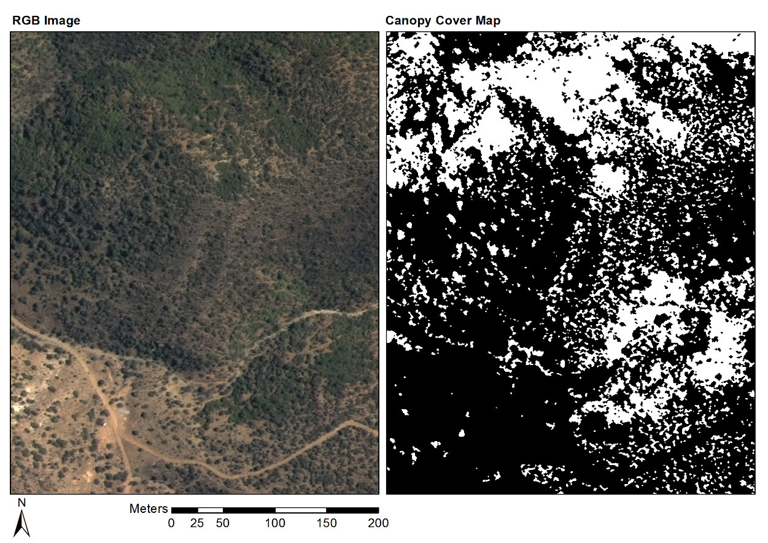

Figure 4.1 Groenfontein classification (Habitat: valley thicket with Spekboom)

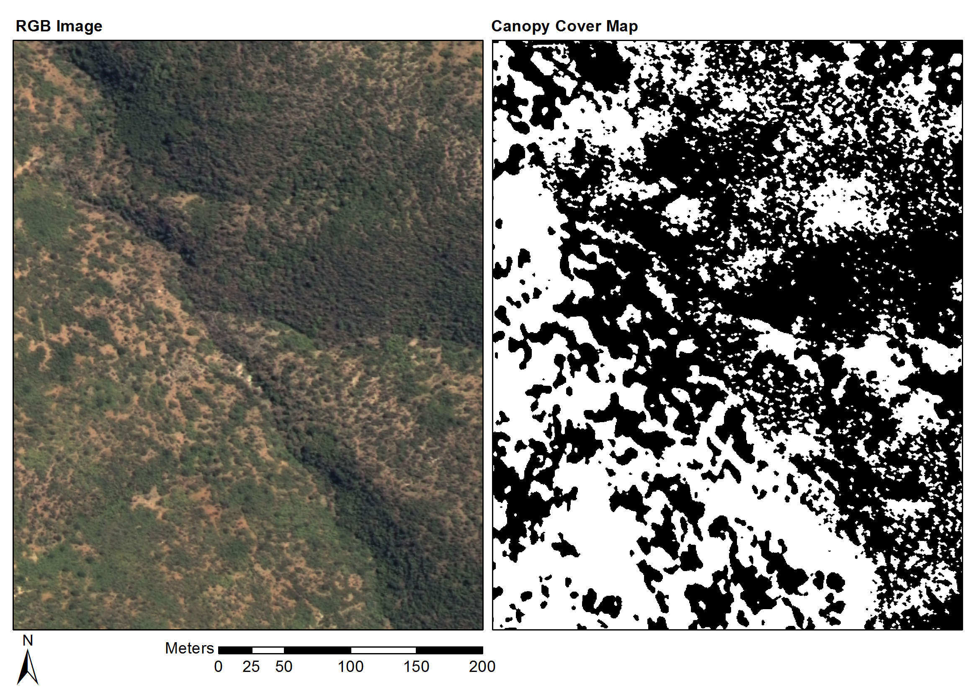

Figure 4.2 Matjiesvlei classification (Habitat: arid thicket with Spekboom)

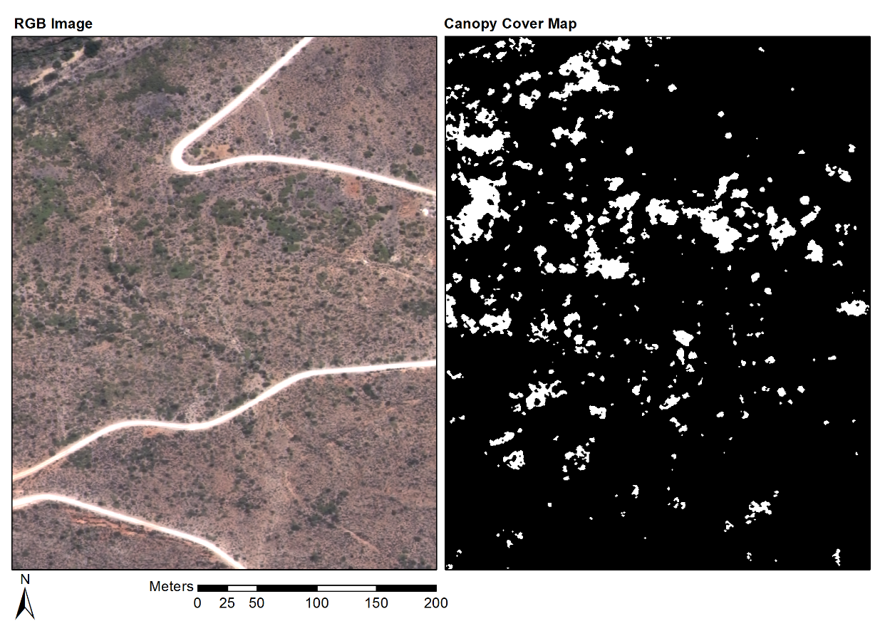

Figure 4.3 Rooiberg classification (Habitat: arid thicket with Spekboom and Fynbos mosaic)

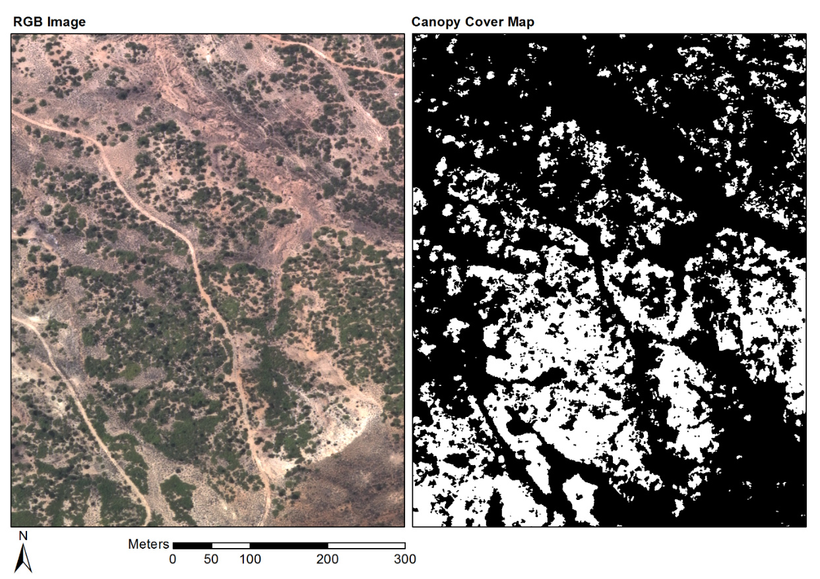

Figure 4.4 Grootkop classification (Habitat: arid thicket with Spekboom and Succulent Karoo mosaic)

# Conclusions

A per-pixel classification approach was adopted to map *P. afra* canopy cover using VHR aerial imagery. A mean absolute canopy cover error of 5.85% and standard deviation of 4.65% over 20 field ground truth sites was obtained. These figures compare well with related studies (Baraldi et al., 2010; Ghosh and Joshi, 2014; Heumann, 2011; Johansen et al., 2007; Mehner et al., 2004). VHR vegetation mapping over large areas such as the Little Karoo is still relatively uncommon, especially in arid regions (Eisfelder et al., 2012; Lu, 2006). This research represents a potentially valuable addition to this growing field.

While the classification accuracies are good, a number of opportunities exist for improving the technical aspects of the method. Adopting an object based approach would allow more sophisticated texture measures to be incorporated into the feature set. This could facilitate better discrimination of *P. afra* from surrounding vegetation. Incorporation of ancillary information such as slope aspect and habitat type could also improve classification accuracy and the ability to generalise over diverse habitats. In terms of the application of these techniques to restoration work, this map could be extended to the rest of the thicket biome in future, by incorporating ground truth from new sites. It would likely be necessary to re-train the classifier for new areas. This work represents a first step towards the estimation of carbon stocks (total above ground carbon (TAGC)) in thicket. Powell (2009) found that *P. afra* canopy cover was correlated with TAGC (R2=0.516).

# References

Baraldi, A., Durieux, L., Simonetti, D., Conchedda, G., Holecz, F., Blonda, P., 2010. Automatic spectral-rule-based preliminary classification of radiometrically calibrated SPOT-4/-5/IRS, AVHRR/MSG, AATSR, IKONOS/QuickBird/OrbView/GeoEye, and DMC/SPOT-1/-2 imagery—Part I: System design and implementation. IEEE Transactions on Geoscience and Remote Sensing 48, 1299–1325.

Chandelier, L., Martinoty, G., 2009. A radiometric aerial triangulation for the equalization of digital aerial images and orthoimages. Photogrammetric Engineering & Remote Sensing 75, 193–200.

Collings, S., Caccetta, P., Campbell, N., Wu, X., 2011. Empirical models for radiometric calibration of digital aerial frame mosaics. IEEE Transactions on Geoscience and Remote Sensing 49, 2573–2588. doi:10.1109/TGRS.2011.2108301

Eisfelder, C., Kuenzer, C., Dech, S., 2012. Derivation of biomass information for semi-arid areas using remote-sensing data. International Journal of Remote Sensing 33, 2937–2984.

Gehrke, S., 2010. Radiometric processing of ADS imagery: mosaicking of large image blocks, in: Opportunities for Emerging Geospatial Technologies, American Society for Photogrammetry and Remote Sensing Annual Conference 2010 Held 26-30 April 2010. American Society for Photogrammetry and Remote Sensing, San Diego, USA, pp. 184–195.

Ghosh, A., Joshi, P.K., 2014. A comparison of selected classification algorithms for mapping bamboo patches in lower Gangetic plains using very high resolution WorldView 2 imagery. International Journal of Applied Earth Observation and Geoinformation 26, 298–311. doi:10.1016/j.jag.2013.08.011

Heumann, B.W., 2011. Satellite remote sensing of mangrove forests: Recent advances and future opportunities. Progress in Physical Geography 35, 87–108. doi:10.1177/0309133310385371

Intergraph, 2008. Digital mapping camera system [WWW Document]. URL http://www.geospace.co.za/pdf/DMC Brochure.pdf

Johansen, K., Coops, N.C., Gergel, S.E., Stange, Y., 2007. Application of high spatial resolution satellite imagery for riparian and forest ecosystem classification. Remote Sensing of Environment 110, 29–44. doi:10.1016/j.rse.2007.02.014

López, D.H., García, B.F., Piqueras, J.G., Guillermo, V.A., 2011. An approach to the radiometric aerotriangulation of photogrammetric images. ISPRS Journal of Photogrammetry and Remote Sensing 66, 883–893. doi:10.1016/j.isprsjprs.2011.09.011

Lu, D., 2006. The potential and challenge of remote sensing based biomass estimation. International Journal of Remote Sensing 27, 1297–1328. doi:10.1080/01431160500486732

Marais, C., Cowling, R.M., Powell, M., 2009. Establishing the platform for a carbon sequestration market in South Africa: The Working for Woodlands Subtropical Thicket Restoration Programme, in: XIII World Forestry Congress. Buenos Aires, Argentina, pp. 1–13.

Mehner, H., Cutler, M., Fairbairn, D., Thompson, G., 2004. Remote sensing of upland vegetation: the potential of high spatial resolution satellite sensors. Global Ecology and Biogeography 13, 359–369. doi:10.1111/j.1466-822X.2004.00096.x

Mills, A.J., Blignaut, J., Cowling, R.M., Knipe, A., Marais, C., Marais, S., Pierce, S., Powell, M., Sigwela, A., Skowno, A., 2010. Investing in sustainability. Restoring degraded thicket, creating jobs, capturing carbon and earning green credit., Published by Climate Action Partnership, Cape Town, and Wilderness Foundation, Port Elizabeth, Series. Climate Action Partnership, Cape Town and Wilderness Foundation, Port Elizabeth.

Mills, A.J., Cowling, R.M., 2006. Rate of carbon sequestration at two thicket restoration sites in the Eastern Cape, South Africa. Restoration Ecology 14, 38–49.

Mills, A.J., Cowling, R.M., Fey, M., Kerley, G., Donaldson, J., Sigwela, A., Skowno, A., Rundel, P., 2005. Effects of goat pastoralism on ecosystem carbon storage in semiarid thicket, Eastern Cape, South Africa. Austral Ecology 30, 797–804.

National Geo-spatial Information, 2012. National aerial photography and imagery programme [WWW Document]. Department of Rural Development and Land Reform (DRDLR). URL http://www.ngi.gov.za/index.php/Image-tabs-home/national-aerial-photography-and-imagery-programme.html (accessed 5.22.12).

Powell, M.J., 2009. Restoration of degraded subtropical thickets in the Baviaanskloof Megareserve, South Africa (No. MSc. thesis), Series. Master’s thesis. Grahamstown: Rhodes University, Department of Environmental Science.

Sahu, B., Mishra, D., 2011. A novel approach for selecting informative genes from gene expression data using signal-to-noise ratio and t-statistics, in: 2011 2nd International Conference on Computer and Communication Technology (ICCCT-2011). IEEE, Allahabad, India, pp. 5–10. doi:10.1109/ICCCT.2011.6075207

Sigwela, A., Kerley, G., Mills, A.J., Cowling, R.M., 2009. The impact of browsing-induced degradation on the reproduction of subtropical thicket canopy shrubs and trees. South African Journal of Botany 75, 262–267. doi:10.1016/j.sajb.2008.12.001

Singh, M., Malhi, Y., Bhagwat, S., 2014. Biomass estimation of mixed forest landscape using a Fourier transform texture-based approach on very-high-resolution optical satellite imagery. International Journal of Remote Sensing 35, 3331–3349. doi:10.1080/01431161.2014.903441

Strobl, C., Boulesteix, A.-L., Kneib, T., Augustin, T., Zeileis, A., 2008. Conditional variable importance for random forests. BMC bioinformatics 9, 307. doi:10.1186/1471-2105-9-307

Tolosi, L., Lengauer, T., 2011. Classification with correlated features: unreliability of feature ranking and solutions. Bioinformatics 27, 1986–1994. doi:10.1093/bioinformatics/btr300

van der Vyver, M.L., Cowling, R.M., Mills, A.J., Difford, M., 2013. Spontaneous return of biodiversity in restored subtropical thicket: Portulacaria afra as an ecosystem engineer. Restoration Ecology 21, 736–744. doi:10.1111/rec.12000

van Luijk, G., Cowling, R.M., Riksen, M.J.P.M., Glenday, J., 2013. Hydrological implications of desertification: Degradation of South African semi-arid subtropical thicket. Journal of Arid Environments 91, 14–21. doi:10.1016/j.jaridenv.2012.10.022

Vlok, J., Cowling, R.M., Wolf, T., 2005. A vegetation map for the Little Karoo. Unpublished maps and report for a SKEP project supported by CEPF grant no 1064410304.

Yousef, M., Jung, S., Showe, L.C., Showe, M.K., 2007. Recursive cluster elimination (RCE) for classification and feature selection from gene expression data. BMC Bioinformatics 8. doi:10.1186/1471-2105-8-144

Yu, L., Liu, H., 2004. Efficient feature selection via analysis of relevance and redundancy. Journal of Machine Learning Research 5, 1205–1224.